附录A：

实验七:最短路径Dijstra 与 Floyd-Warshal 算法实现

姓 名： 邓杰湧
学 号： 2023212351
班 级： 物联网工程23-1班
实验地点： 翡翠科教楼C306
实验时间： 2024.11.12 7-10节

- 实验目的和要求
(1). 借助已有平台基于 Dijkstra 算法求解最短路径，要求图形化显 示并文本输出相关路径。 (2). 借助已有平台基于 Floyd-Warshall 算法求解最短路径，要求图 形化显示并文本输出相关路径。
- 实验环境和工具
环境：python:visual code

- 实验结果
  - 算法核心流程图
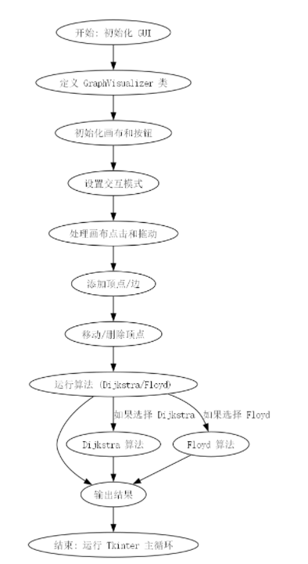
  - 关键代码
import tkinter as tk
from tkinter import simpledialog, messagebox
import math

# 定义图的可视化类
class GraphVisualizer:
def __init__(self, root):
self.root = root
self.root.title("Graph Visualizer")
# 创建一个 canvas 用于绘制图
self.canvas = tk.Canvas(root, width=800, height=600, bg="white")
self.canvas.pack()

# 定义变量
self.vertices = {} # 存储顶点的字典，键为顶点名称，值为 (x, y) 坐标
self.edges = {} # 存储边的字典，键为 (start, end) 顶点对，值为权重
self.selected_vertex = None # 当前选中的顶点
self.source = None # 源点
self.destination = None # 终点
self.mode = None # 操作模式: "add" 添加顶点, "edge" 添加边, "move" 移动顶点, "delete" 删除顶点, "source" 选择源点, "destination" 选择终点

# 创建按钮
self.add_vertex_btn = tk.Button(root, text="添加顶点", command=self.set_add_mode)
self.add_vertex_btn.pack(side=tk.LEFT)
self.add_edge_btn = tk.Button(root, text="添加边", command=self.set_edge_mode)
self.add_edge_btn.pack(side=tk.LEFT)
self.move_vertex_btn = tk.Button(root, text="移动顶点", command=self.set_move_mode)
self.move_vertex_btn.pack(side=tk.LEFT)
self.delete_vertex_btn = tk.Button(root, text="删除顶点", command=self.set_delete_mode)
self.delete_vertex_btn.pack(side=tk.LEFT)
self.source_btn = tk.Button(root, text="选择源点", command=self.set_source_mode)
self.source_btn.pack(side=tk.LEFT)
self.destination_btn = tk.Button(root, text="选择终点", command=self.set_destination_mode)
self.destination_btn.pack(side=tk.LEFT)
self.dijkstra_btn = tk.Button(root, text="Dijkstra 算法", command=self.run_dijkstra)
self.dijkstra_btn.pack(side=tk.LEFT)
self.floyd_btn = tk.Button(root, text="Floyd 算法", command=self.run_floyd)
self.floyd_btn.pack(side=tk.LEFT)

# 绑定 canvas 事件
self.canvas.bind("<Button-1>", self.on_canvas_click)
self.canvas.bind("<B1-Motion>", self.on_canvas_drag)

# 设置添加顶点模式
def set_add_mode(self):
self.mode = "add"

# 设置添加边模式
def set_edge_mode(self):
self.mode = "edge"

# 设置移动顶点模式
def set_move_mode(self):
self.mode = "move"

# 设置删除顶点模式
def set_delete_mode(self):
self.mode = "delete"

# 设置选择源点模式
def set_source_mode(self):
self.mode = "source"

# 设置选择终点模式
def set_destination_mode(self):
self.mode = "destination"

# 处理 canvas 点击事件
def on_canvas_click(self, event):
if self.mode == "add":
self.add_vertex(event.x, event.y)
elif self.mode == "edge":
self.add_edge(event.x, event.y)
elif self.mode == "move":
self.select_vertex(event.x, event.y)
elif self.mode == "delete":
self.delete_vertex(event.x, event.y)
elif self.mode == "source":
self.select_source(event.x, event.y)
elif self.mode == "destination":
self.select_destination(event.x, event.y)

# 处理 canvas 拖动事件
def on_canvas_drag(self, event):
if self.mode == "move" and self.selected_vertex:
self.move_vertex(event.x, event.y)

# 添加顶点
def add_vertex(self, x, y):
name = f"V{len(self.vertices) + 1}" # 生成新的顶点名称
self.vertices[name] = (x, y) # 存储顶点坐标
self.draw_vertex(name, x, y) # 绘制顶点

# 绘制顶点
def draw_vertex(self, name, x, y):
self.canvas.create_oval(x - 15, y - 15, x + 15, y + 15, fill="lightgray", tags=name) # 绘制顶点圆
self.canvas.create_text(x, y, text=name, tags=name) # 绘制顶点名称

# 添加边
def add_edge(self, x, y):
vertex = self.get_vertex_at_position(x, y) # 获取点击位置的顶点
if vertex:
if self.selected_vertex:
weight = simpledialog.askinteger("权重", "输入边的权重：", minvalue=1) # 弹出对话框输入边的权重
if weight:
self.edges[(self.selected_vertex, vertex)] = weight # 存储边的权重
self.draw_edge(self.selected_vertex, vertex, weight) # 绘制边
self.selected_vertex = None # 重置选中的顶点
else:
self.selected_vertex = vertex # 选中起点顶点

# 绘制边
def draw_edge(self, start, end, weight):
x1, y1 = self.vertices[start] # 获取起点坐标
x2, y2 = self.vertices[end] # 获取终点坐标
self.canvas.create_line(x1, y1, x2, y2, arrow=tk.LAST) # 绘制带箭头的边
self.canvas.create_text((x1 + x2) // 2, (y1 + y2) // 2, text=str(weight)) # 绘制边的权重

# 选中顶点
def select_vertex(self, x, y):
self.selected_vertex = self.get_vertex_at_position(x, y) # 获取点击位置的顶点

# 移动顶点
def move_vertex(self, x, y):
if self.selected_vertex:
self.vertices[self.selected_vertex] = (x, y) # 更新顶点坐标
self.redraw() # 重新绘制整个图

# 删除顶点
def delete_vertex(self, x, y):
vertex = self.get_vertex_at_position(x, y) # 获取点击位置的顶点
if vertex:
del self.vertices[vertex] # 删除顶点
self.edges = {(u, v): w for (u, v), w in self.edges.items() if u != vertex and v != vertex} # 删除与该顶点相关的所有边
self.redraw() # 重新绘制整个图

# 选择源点
def select_source(self, x, y):
vertex = self.get_vertex_at_position(x, y) # 获取点击位置的顶点
if vertex:
self.source = vertex # 设置源点
self.redraw() # 重新绘制整个图

# 选择终点
def select_destination(self, x, y):
vertex = self.get_vertex_at_position(x, y) # 获取点击位置的顶点
if vertex:
self.destination = vertex # 设置终点
self.redraw() # 重新绘制整个图

# 获取点击位置的顶点
def get_vertex_at_position(self, x, y):
for name, (vx, vy) in self.vertices.items():
if (x - vx) ** 2 + (y - vy) ** 2 <= 15 ** 2: # 检查点击位置是否在顶点范围内
return name
return None

# 重新绘制整个图
def redraw(self):
self.canvas.delete("all") # 清除 canvas 上的所有内容
for (start, end), weight in self.edges.items():
self.draw_edge(start, end, weight) # 重新绘制所有边
for name, (x, y) in self.vertices.items():
self.draw_vertex(name, x, y) # 重新绘制所有顶点
if self.source:
x, y = self.vertices[self.source]
self.canvas.create_oval(x - 15, y - 15, x + 15, y + 15, fill="red", tags=self.source) # 高亮显示源点
self.canvas.create_text(x, y, text=self.source, tags=self.source)
if self.destination:
x, y = self.vertices[self.destination]
self.canvas.create_oval(x - 15, y - 15, x + 15, y + 15, fill="blue", tags=self.destination) # 高亮显示终点
self.canvas.create_text(x, y, text=self.destination, tags=self.destination)

# 运行 Dijkstra 算法
def run_dijkstra(self):
if not self.source or not self.destination:
messagebox.showerror("错误", "请先选择源点和终点") # 提示用户选择源点和终点
return
distances, previous = self.dijkstra() # 计算最短路径
path = self.get_path(previous, self.destination) # 获取路径
if distances[self.destination] == math.inf:
messagebox.showinfo("结果", "无法到达终点") # 提示无法到达终点
else:
messagebox.showinfo("结果", f"最短路径长度: {distances[self.destination]}\n路径: {' -> '.join(path)}") # 显示最短路径长度和路径

# Dijkstra 算法实现
def dijkstra(self):
distances = {vertex: math.inf for vertex in self.vertices} # 初始化所有顶点的距离为无穷大
previous = {vertex: None for vertex in self.vertices} # 初始化所有顶点的前驱为 None
distances[self.source] = 0 # 源点的距离为 0
unvisited = set(self.vertices) # 未访问的顶点集合

while unvisited:
current = min(unvisited, key=lambda vertex: distances[vertex]) # 选择距离最小的顶点
unvisited.remove(current) # 从未访问集合中移除该顶点

if distances[current] == math.inf:
break # 如果距离为无穷大，说明无法到达

for neighbor in self.get_neighbors(current):
alt = distances[current] + self.edges[(current, neighbor)] # 计算新路径的长度
if alt < distances[neighbor]:
distances[neighbor] = alt # 更新距离
previous[neighbor] = current # 更新前驱

return distances, previous

# 获取顶点的邻居
def get_neighbors(self, vertex):
return [end for (start, end) in self.edges if start == vertex] # 返回所有与该顶点相连的顶点

# 获取路径
def get_path(self, previous, target):
path = []
while target:
path.insert(0, target) # 将顶点插入路径的开头
target = previous[target] # 更新目标顶点为前驱
return path

# 运行 Floyd 算法
def run_floyd(self):
if not self.source or not self.destination:
messagebox.showerror("错误", "请先选择源点和终点") # 提示用户选择源点和终点
return
dist, next_vertex = self.floyd() # 计算最短路径
if dist[self.source][self.destination] == math.inf:
messagebox.showinfo("结果", "无法到达终点") # 提示无法到达终点
else:
path = self.get_floyd_path(next_vertex, self.source, self.destination) # 获取路径
messagebox.showinfo("结果", f"最短路径长度: {dist[self.source][self.destination]}\n路径: {' -> '.join(path)}") # 显示最短路径长度和路径

# Floyd 算法实现
def floyd(self):
n = len(self.vertices)
names = list(self.vertices)
dist = {name: {name2: math.inf for name2 in names} for name in names} # 初始化距离矩阵
next_vertex = {name: {name2: None for name2 in names} for name in names} # 初始化前驱矩阵

for name in names:
dist[name][name] = 0 # 顶点到自身的距离为 0
for (start, end), weight in self.edges.items():
dist[start][end] = weight # 初始化边的权重
next_vertex[start][end] = end # 初始化前驱

for k in names:
for i in names:
for j in names:
if dist[i][j] > dist[i][k] + dist[k][j]:
dist[i][j] = dist[i][k] + dist[k][j] # 更新距离
next_vertex[i][j] = next_vertex[i][k] # 更新前驱

return dist, next_vertex

# 获取 Floyd 算法的路径
def get_floyd_path(self, next_vertex, start, end):
if not next_vertex[start][end]:
return [] # 如果没有路径，返回空列表
path = [start]
while start != end:
start = next_vertex[start][end]
path.append(start)
return path

# 主程序入口
if __name__ == "__main__":
root = tk.Tk() # 创建主窗口
app = GraphVisualizer(root) # 创建图可视化器实例
root.mainloop() # 运行窗口的主事件循环

  - 运行结果
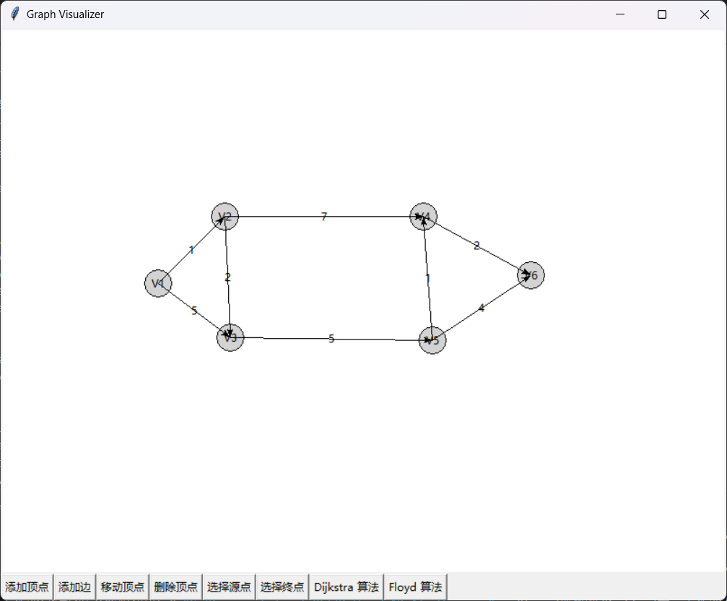
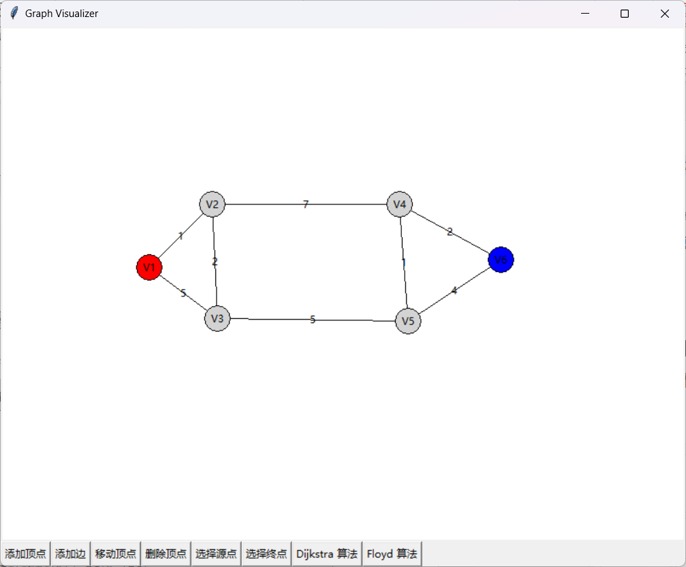
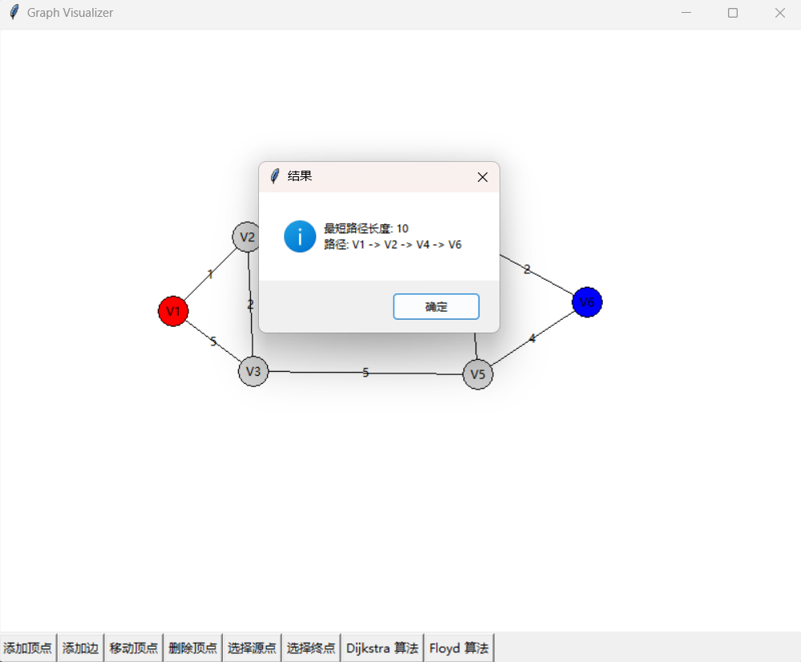

  - 结果分析
通过实验，我们成功设计并实现了一个平台图形化显示并文本输出相关路径。该平台能够通过可视化平台添加节点,删除节点,移动节点,任意选择源点终点来进行Dijkstra算法和Floyd算法可视化.
- 代码与实验结果优化(可选)
平台有些潦草,路径显示得不太清晰是可优化的点.

- 实验心得
该实验个人认为难点在于图形化界面的编写,也是本次实验的重点.我想这个可以再次优化,可以看出这个平台没有显示得很清晰,然后算法展示没有可视化出来,而且没有无向图的选项,这也是可优化的项目.除此之外我认为这个实验给我编程技术有很大的提升,我的代码量也提升了.

